You can use a desktop or laptop, or download the Zoom app on your mobile device.
You can easily join the Tutorial Center’s conference room by clicking this link:
https://cccconfer.zoom.us/j/5593255248
*If you join by clicking the link, go to step 4.
- Or, in your internet browser, go to www.zoom.us
- Click “Join A Meeting”
- Enter the Tutorial Center’s Personal Meeting I.D: and click “Join.”
559-325-5248
- Once you click ”Join”, you will be prompted to either “Open Zoom Meetings” or “Download and run Zoom.” We recommend downloading Zoom.
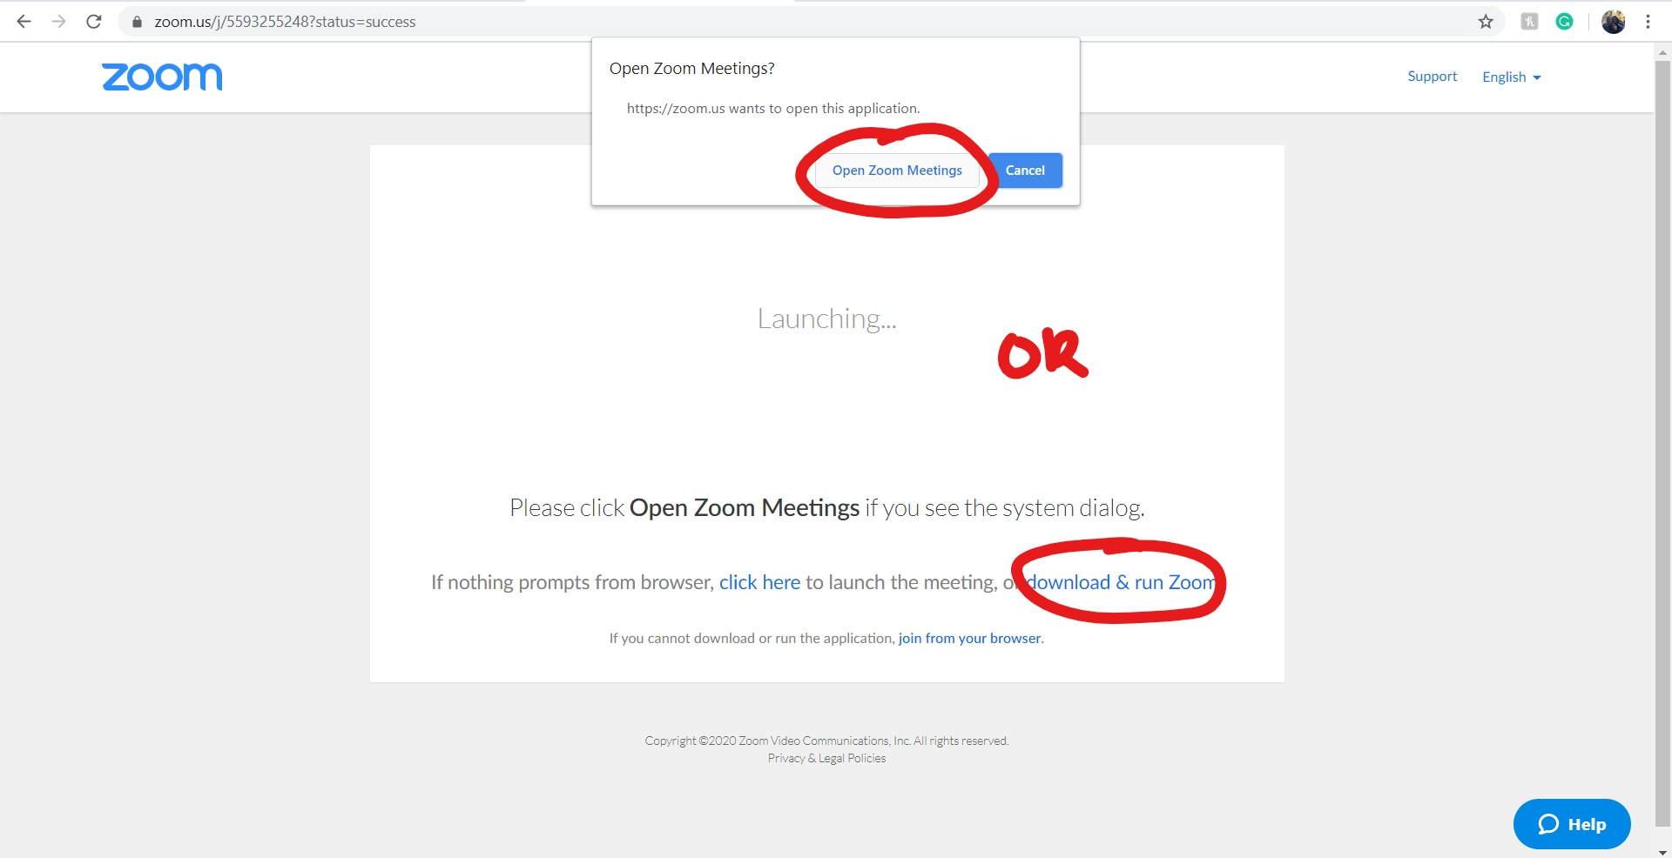
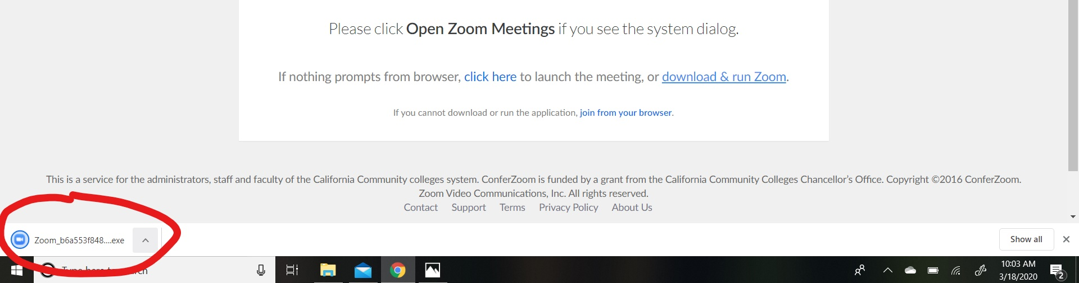
- Click the file and open Zoom.

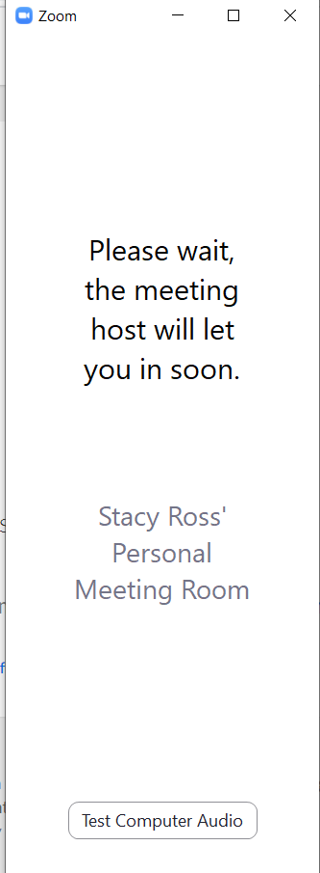
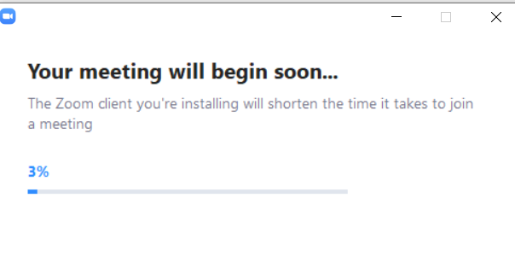
- A few screens will pop up while Zoom loads.
- From there, the coordinator will help get you to the right room. They’ll ask if you are here for writing or STEM help, or assistance with transitioning to online learning.
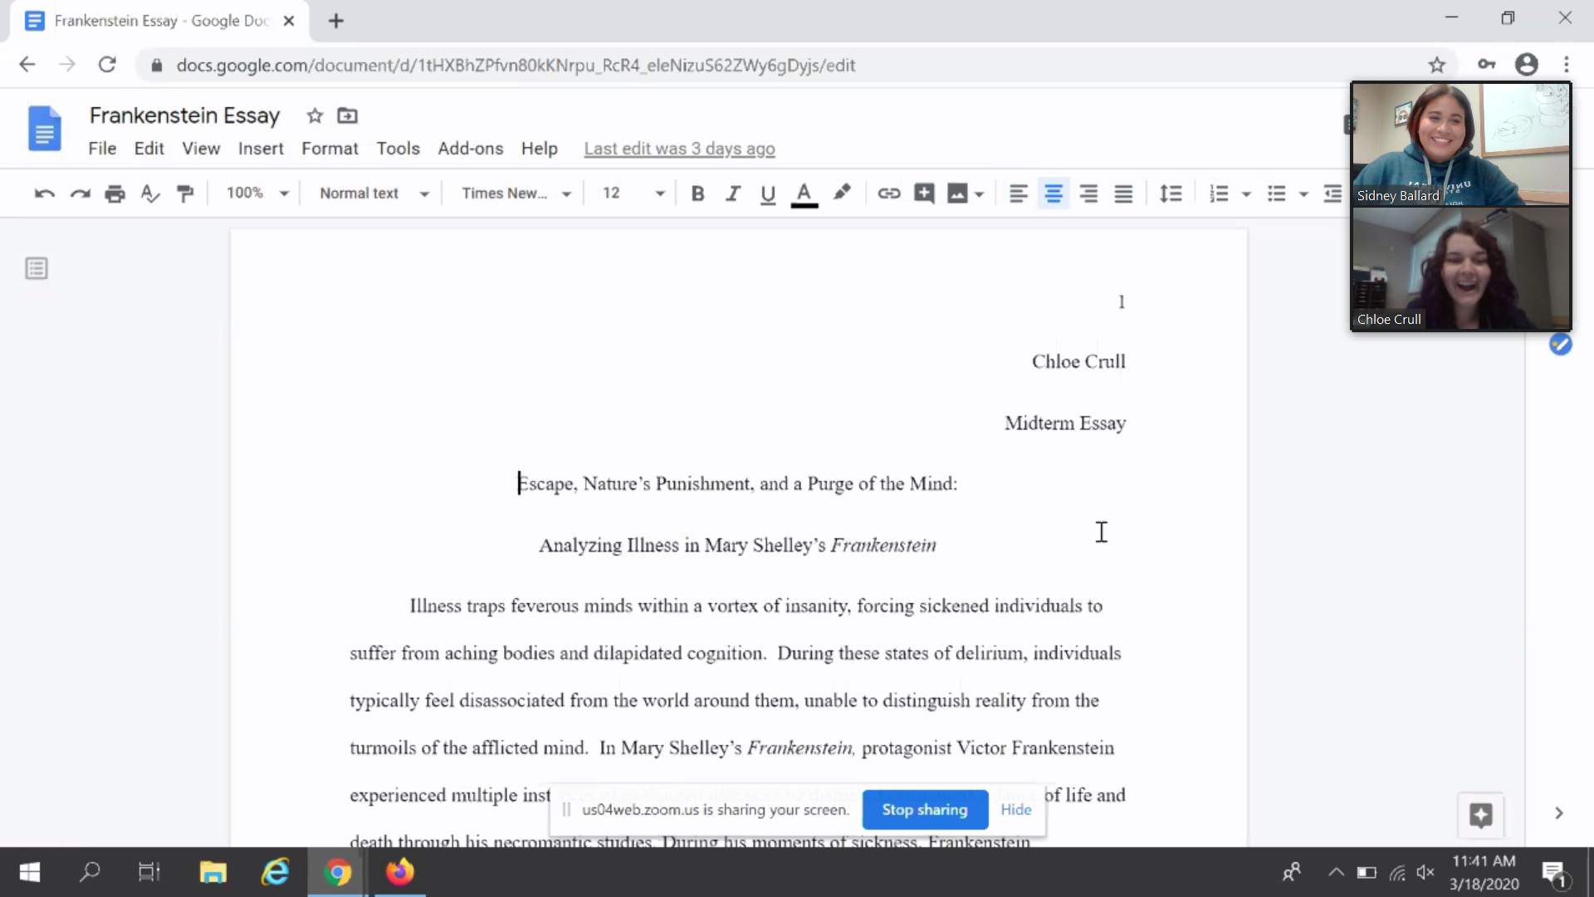
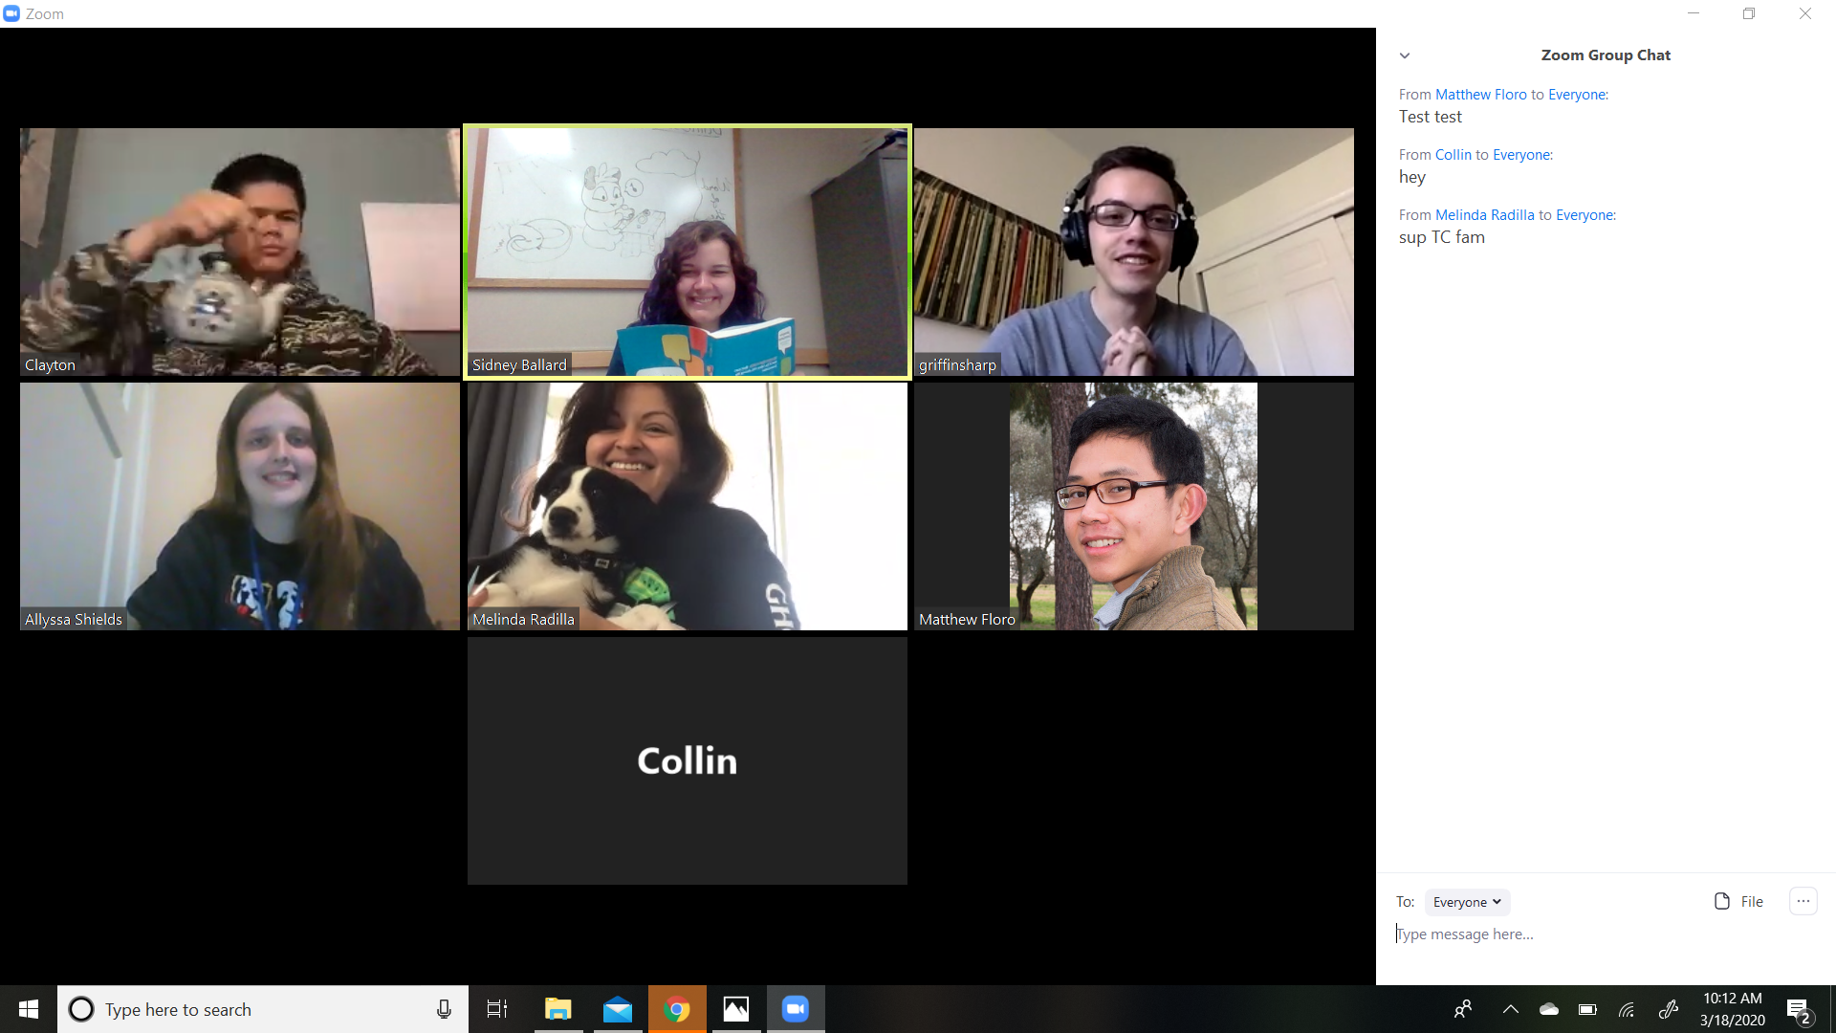
- Depending on what you need assistance with, you may be put into a one-on-one room with a tutor.

