- Open a new window or the document you plan on sharing.
- At the bottom of your screen, click the button titled “Share Screen.”
- Select the other window you prepared. Then, select “Share.”
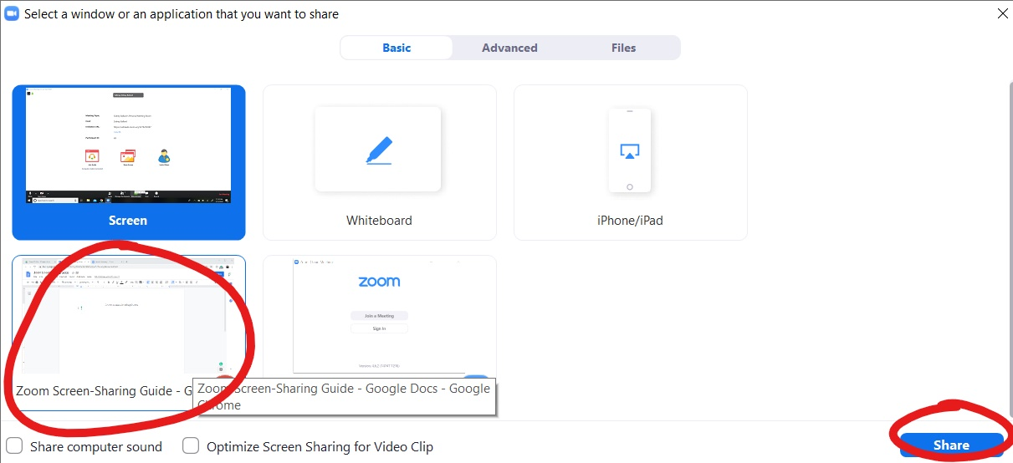
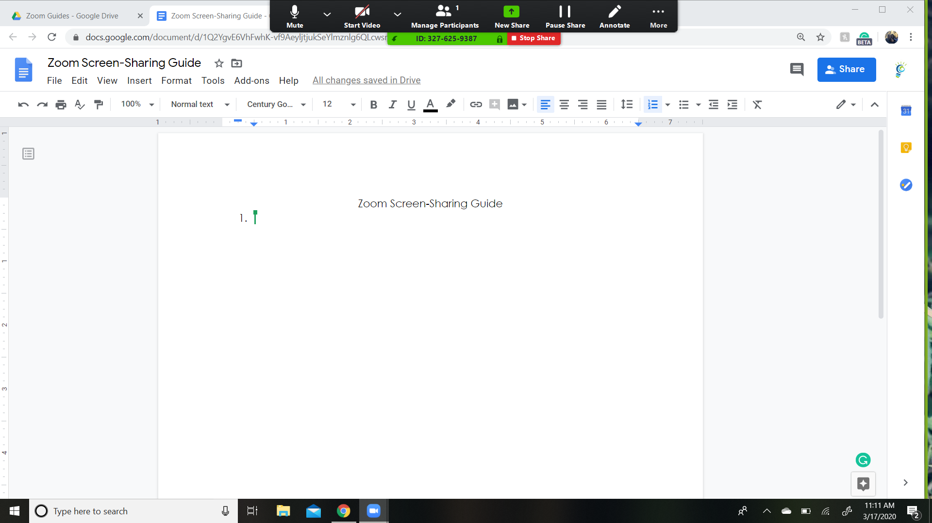
- You are now sharing your screen. All participants should see what you see. It’ll look something like this:

