Practice matching the answers.
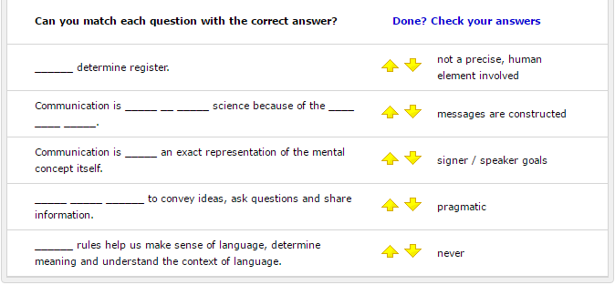

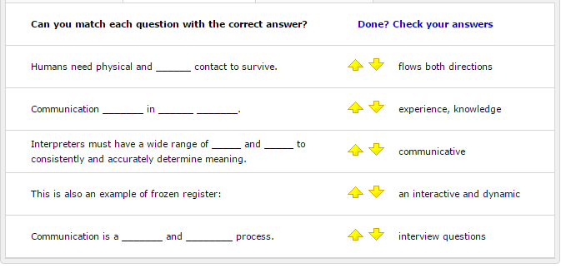

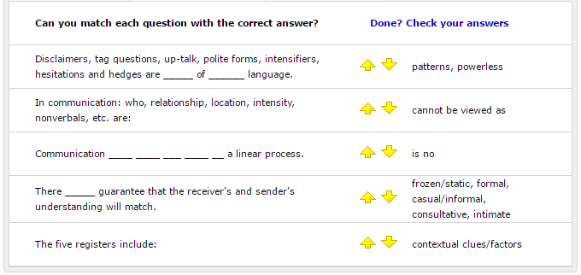

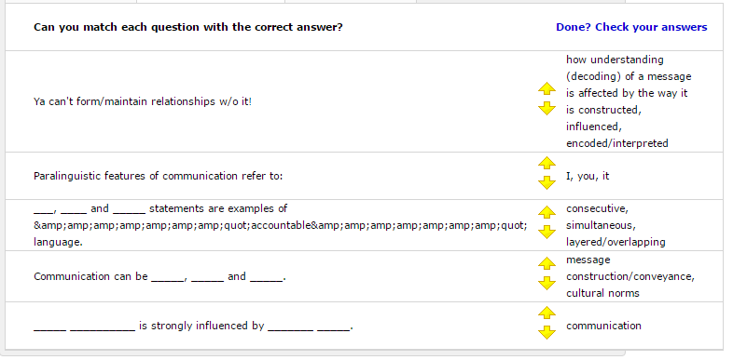
For the 3rd question in the box above, see the prompt/answer for # 36 below-sometimes the system acts quirky.

Also, sometimes extra space was created on the pages below that was not intended. Continue to the next page.
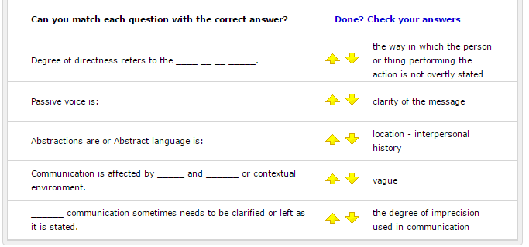
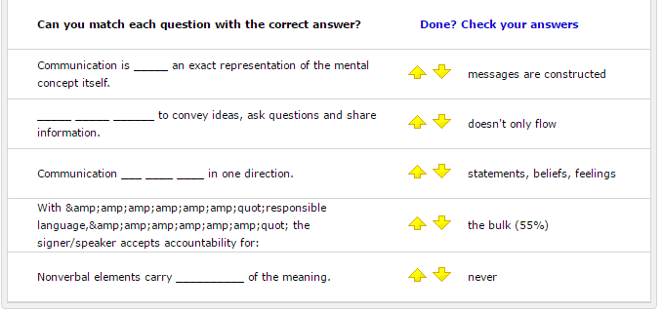

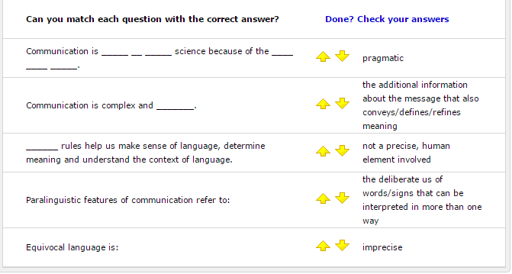
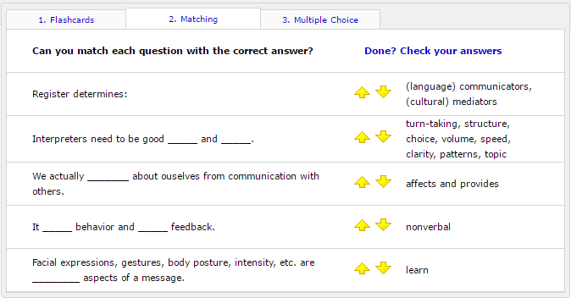

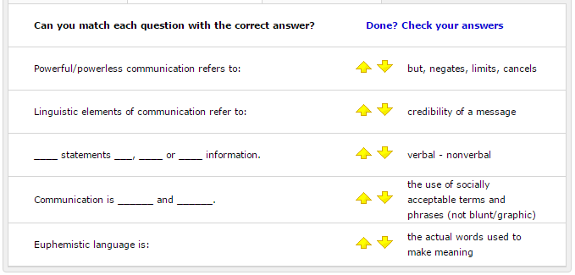
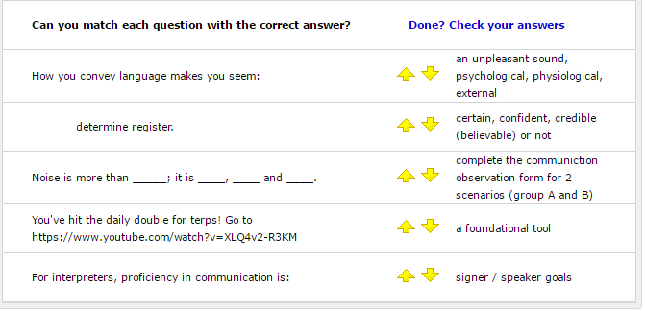

See the form below in association with question # 4 in the box above.

Go to: https://www.youtube.com/watch?v=XLQ4v2-R3KM

Follow the instructions below:

Note from the list below to which group you have been assigned (A or B) to complete the communication observation form (see below) for 1 of 2 scenarios.

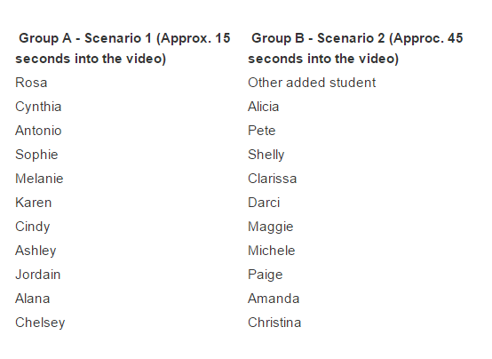

Communication Observation Form
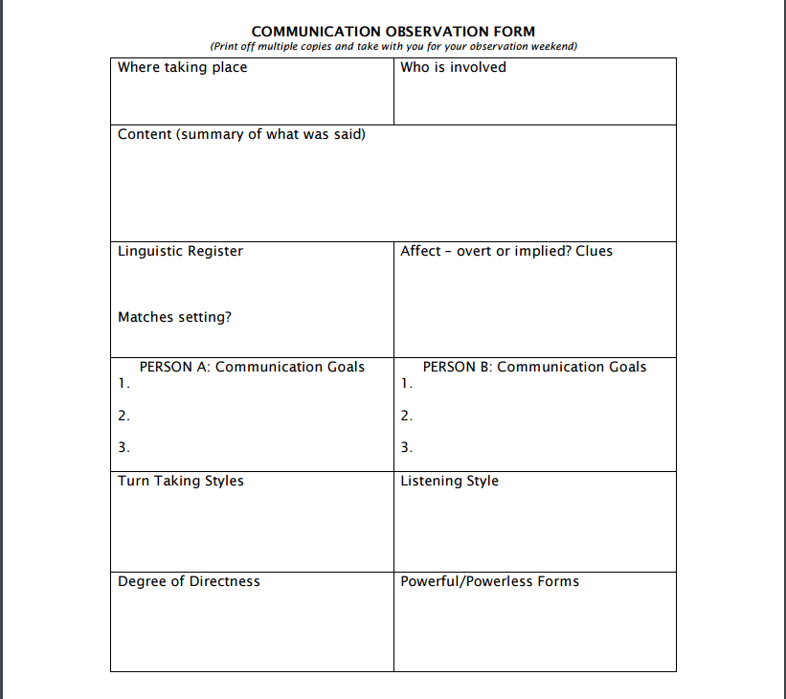

(Flashcard) Answers:
Prompt / Answer

Prompt 1 - Communication is complex and _______.
Answer 1 = imprecise

Prompt 2 - Humans need physical and ______ contact to survive.
Answer 2 - communicative

Prompt 03 - Ya can't form/maintain relationships w/o it!
Answer 03 - communication

Prompt 04 - Communication _____ behavior and _____ feedback.
Answer 04 - affects and provides

Prompt 05 - We actually _______ about ouselves from communication with others.
Answer 05 - learn

Prompt 06 - For interpreters, proficiency in communication is:
Answer 06 - a foundational tool

Prompt 07 - Communication ____ ____ ___ ____ __ a linear process.
Answer 07 - cannot be viewed as

Prompt 08 - Communication ___ ____ ____ in one direction.
Answer 08 - doesn't only flow

Prompt 09 - Communication is _______ and ________ process.
Answer 09 - an interactive and dynamic

Prompt 10 - Communication _______ in ______ _______.
Answer 10 - flows both directions

Prompt 11 - Communication can be _____, _____ and _____.
Answer 11 - consecutive, simultaneous, layered/overlapping

Prompt 12 - Communication is ______ and ______.
Answer 12 - verbal - nonverbal

Prompt 13 - Communication is _____ an exact representation of the mental concept itself.
Answer 13 - never

Prompt 14 - Facial expressions, gestures, body posture, intensity, etc. are ________ aspects of a message.
Answer 14 - nonverbal

Prompt 15 - Nonverbal elements carry __________ of the meaning.
Answer 15 - the bulk (55%)

Prompt 16 - Communication is affected by _____ and ______ or contextual environment.
Answer 16 - location - interpersonal history

Prompt 17 - Noise is more than _____; it is ____, ____ and ____.
Answer 17 - an unpleasant sound, psychological, physiological, external

Prompt 18 - Communication is _____ __ _____ science because of the ____ ____ _____.
Answer 18 - not a precise, human element involved

Prompt 19 - There _____ guarantee that the receiver's and sender's understanding will match.
Answer 19 - is no

Prompt 20 - Good communicators learn to _____ analytically, _____ effectively and ______ clearly all forms of language.
Answer 20 - think, listen, express

Prompt 21 - Your _____ ______ are critical in becoming a professional interpreter.
Answer 21 - people skills

Prompt 22 - ______ rules help us make sense of language, determine meaning and understand the context of language.
Answer 22 - pragmatic

Prompt 23 - In communication: who, relationship, location, intensity, nonverbals, etc. are:
Answer 23 - contextual clues/factors

Prompt 24 - Interpreters must have a wide range of _____ and _____ to consistently and accurately determine meaning.
Answer 24 - experience, knowledge

Prompt 25 - _____ _____ ______ to convey ideas, ask questions and share information.
Answer 25 - messages are constructed

Prompt 26 - Degree of directness refers to the ____ __ __ _____.
Answer 26 - clarity of the message

Prompt 27 - Equivocal language is:
Answer 27 - the deliberate us of words/signs that can be interpreted in more than one way

Prompt 28 - Euphemistic language is:
Answer 28 - the use of socially acceptable terms and phrases (not blunt/graphic)

Prompt 29 - Abstractions are or Abstract language is:
Answer 29 - the degree of imprecision used in communication

Prompt 30 - Passive voice is:
Answer 30 - the way in which the person or thing performing the action is not overtly stated

Prompt 31 - ______ communication sometimes needs to be clarified or left as it is stated.
Answer 31 - vague

Prompt 32 - Powerful/powerless communication refers to:
Answer 32 - credibility of a message

Prompt 33 - Disclaimers, tag questions, up-talk, polite forms, intensifiers, hesitations and hedges are _____ of ______ language.
Answer 33 - patterns, powerless

Prompt 34 - How you convey language makes you seem:
Answer 34 - certain, confident, credible (believable) or not

Prompt 35 - Responsible language refers to:
Answer 35 - accountability in the message

Prompt 36 - ___, ____ and _____ statements are examples of accountable language.
Answer 36 - I, you, it

Prompt 37 - ____ statements ___, ____ or ____ information.
Answer 37 - but, negates, limits, cancels

Prompt 38 - Linguistic register refers to:
Answer 38 - formality in the message

Prompt 39 - Register determines:
Answer 39 - turn-taking, structure, choice, volume, speed, clarity, patterns, topic

Prompt 40 - ______ determine register.
Answer 40 - signer / speaker goals

Prompt 41 - The five registers include:
Answer 41 - frozen/static, formal, casual/informal, consultative, intimate

Prompt 42 - _____ __________ is strongly influenced by _______ _____.
Answer 42 - message construction/conveyance, cultural norms

Prompt 43 - With "responsible language" the signer/speaker accepts accountability for:
Answer 43 - statements, beliefs, feelings

Prompt 44 - Paralinguistic features of communication refer to:
Answer 44 - how understanding (decoding) of a message is affected by the way it is constructed, influenced, encoded/interpreted

Prompt 45 - Linguistic elements of communication refer to:
Answer 45 - the actual words used to make meaning

Prompt 46 - Paralinguistic features of communication refer to:
Answer 46 - the additional information about the message that also conveys/defines/refines meaning

Prompt 47 - Interpreters need to be good _____ and _____.
Answer 47 - (language) communicators, (cultural) mediators

Prompt 48 - You've hit the “daily double” for terps! Go to https://www.youtube.com/watch?v=XLQ4v2-R3KM
Answer 48 - complete the communication observation form for 2 scenarios (group A and B)

Prompt 49 - This is also an example of frozen register:
Answer 49 -interview questions

Prompt 50 - The Pledge of Allegiance is an example of what kind of register?
Answer 50 - Frozen/static register

